-
1. DISASTER OP #: 2. SOURCE OF INFORMATION (Report verified by): 3. REPORT DATE:
Part II DECEASED INFORMATION O O ME/coroner Physician OO Family/iFire Dept/Police ndividual OO OtherNot verified , specify: MM DD YYYY
4. NAME: 5. DATE OF BIRTH: O Unknown 6. AGE (YEARS): O Unknown
O < 1 year
________________________ ______________________
LAST FIRST MM DD YYYY
7. RESIDENTIAL ADDRESS OF DECEASED: 8. DATE OF DEATH: DATE OF BODY RECOVERY:

_________________________
STATE ZIPCODE COUNTY MM DD YYYY MM DD YYYY

_________________________________________ ___________________________ STREET ADDRESS CITY O Missing, presumed dead O Recovery Date same as Date of Death
9. RACE (Check all that apply): O American Indian or Alaskan Native O Asian 10.ETHNICITY: 11.GENDER: O Male
O White O Black/African American O Native Hawaiian or Pacific Islander O Other O Hispanic O Non-Hispanic O Unknown O Female
12. LOCATION OF INJURY OR ONSET OF ILLNESS: If same address as #7; check here O
O Mobile home O Single family residence O Unknown
O Motor vehicle O Outside O Other, ^{specify:} STATE ADDRESS and ZIP CODE
13. LOCATION OF DEATH/BODY RECOVERY: If same address as #7; check here O
O Hospital O Decedent’s home O Unknown
O Motor vehicle O Outside O Other, specify: STATE ADDRESS and ZIP CODE
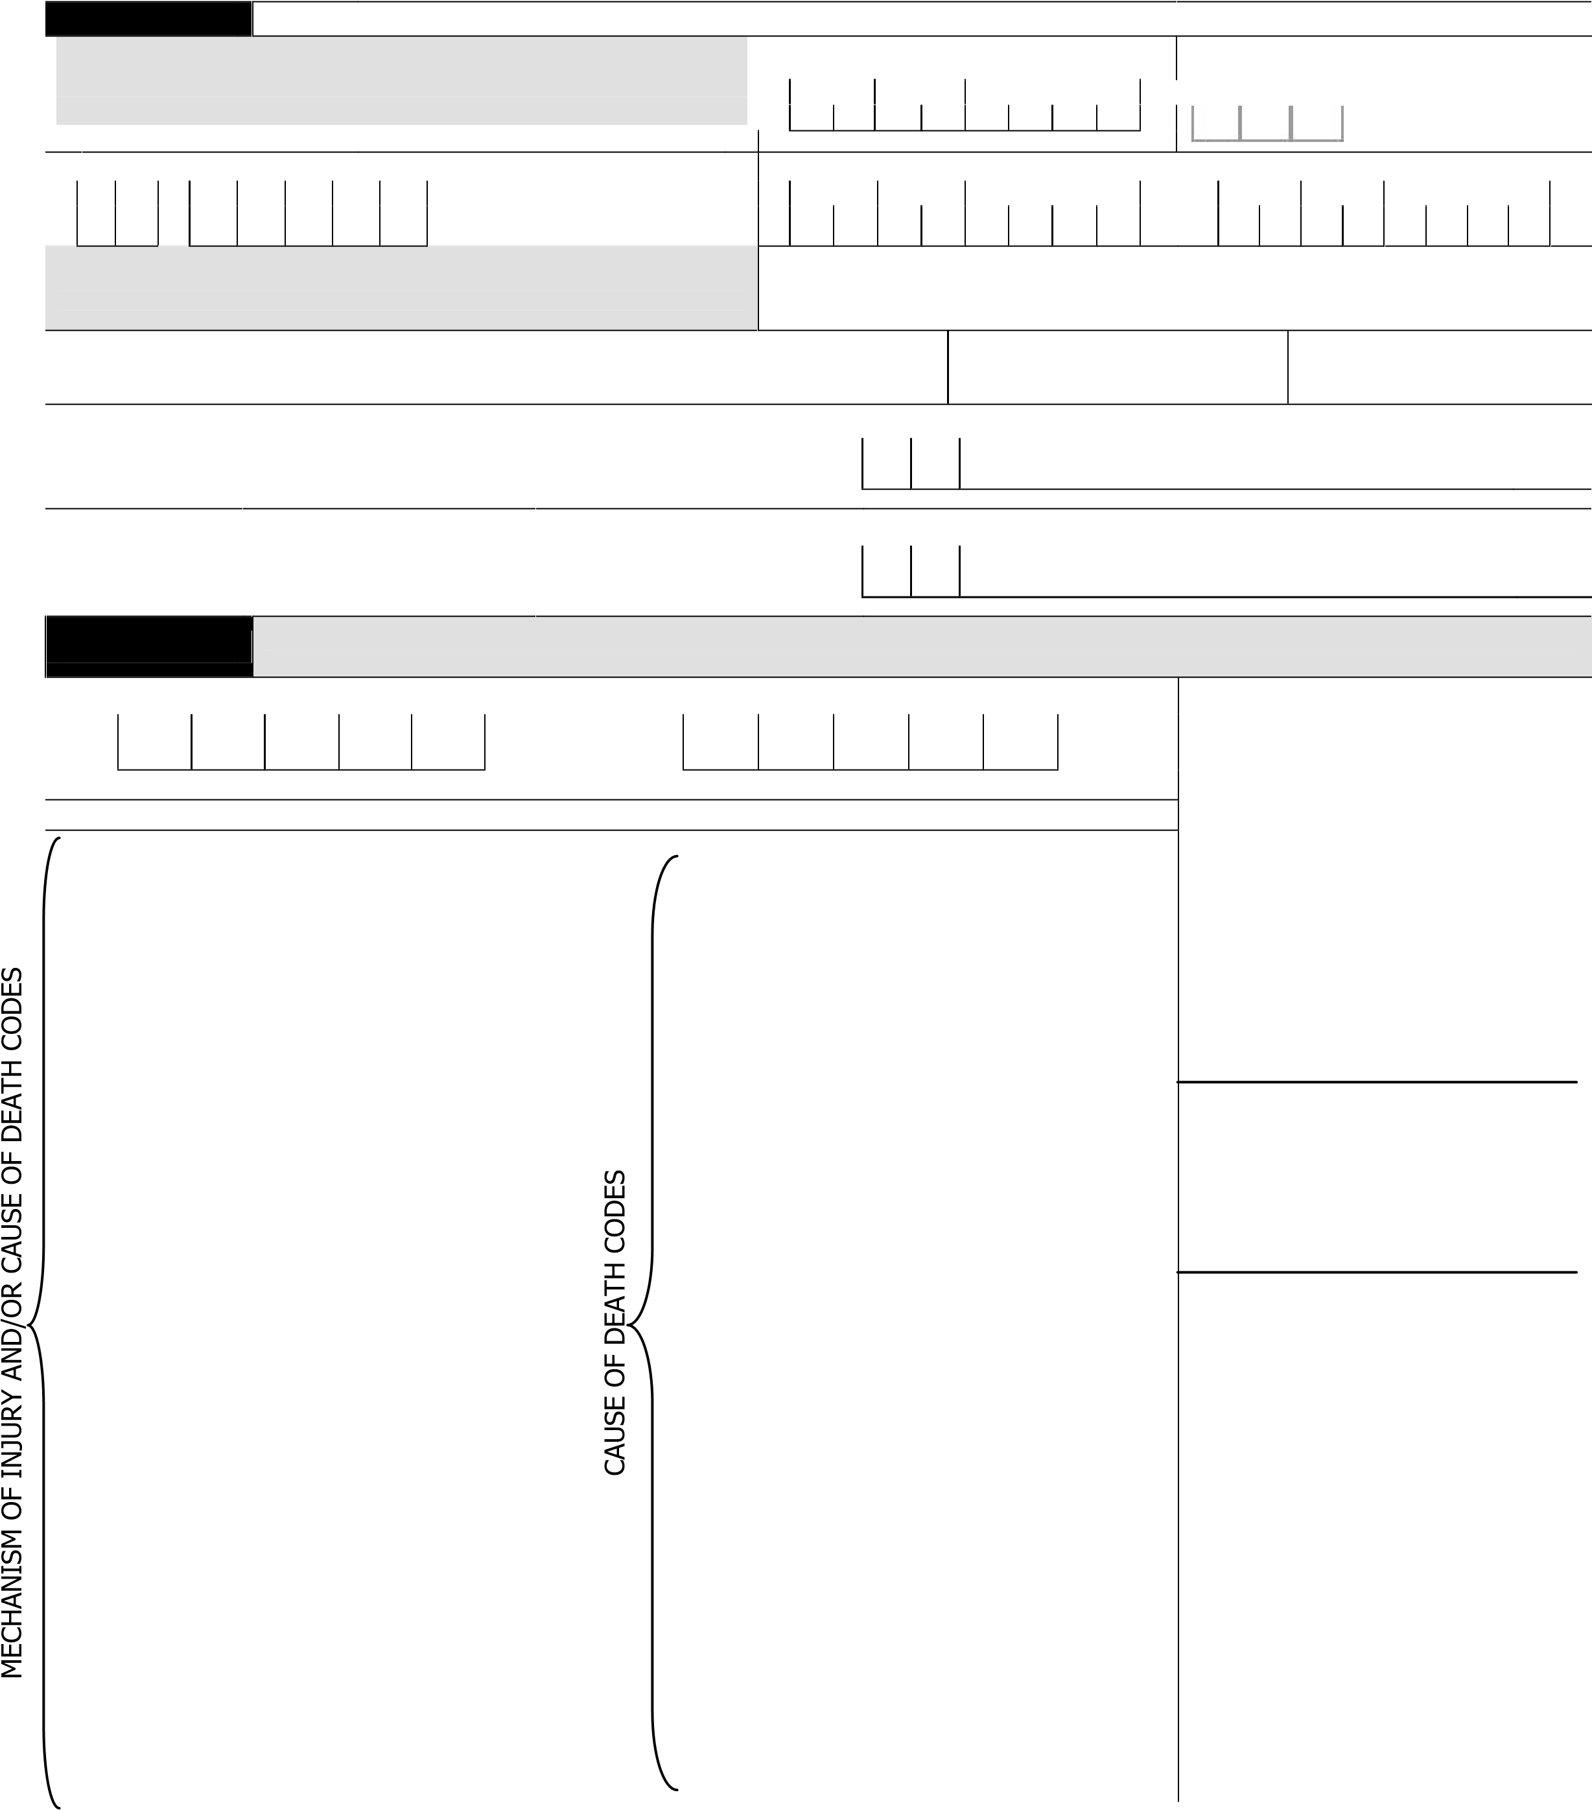
Part III CAUSE AND CIRCUMSTANCES OF DEATH (Use the codes below to mark the category that best applies. For example, if driver died of a heart attack preceded by a MVA, code Mechanism as 07- 01 and COD as 51- 01)

14. MECHANISM OF INJURY* 15. IMMEDIATE CAUSE OF DEATH*

— —

USE 4-DIGIT MECH OF INJURY CODE USE 4-DIGIT CAUSE OF DEATH OR MECH OF INJURY CODE
*MECHANISM OF INJURY CODES INCLUDE 00-00 to 18-00, CAUSE OF DEATH INCLUDE ANY BELOW
16. WAS THE DEATH

O DIRECTLY caused by disaster
(e.g., structural collapse, struck by flying debris, swept away by water,

00-0 NO INJURY
01-00 Burns
01-01 fire / flames 01-02 chemical /caustics
02-00 Crushed in or between objects
03-00 Cut/struck by or against,
03-01 debris
03-02machinery/tools/equipment/chainsaw
03-03 other, specify
04-00 Drowning / submersion 05-00 Electric current (e.g., cables / lines) 06-00 Fall, specify:
 |  | Form 2077A v3 Rev. 2/2013
Disaster Health Services Mortality Report Form

Complete one form per decedent. Email form to Mary.CaseyLockyer@redcross.org or fax to
202- 303- 0225
Part I | GENERAL INFORMATION
06-01 from one level to another (e.g., down stairs; from ladder, building, or tree)
06-02 on same level
07-00 Motor vehicle /transport, specify:
07-01 driver
07-02 passenger / occupant
07-03 pedestrian / bicyclist
07-04 bicyclist 08-00 Poisoning, specify:
08-01 toxic effect of carbon monoxide
08-02 inhalation of gases, fumes, vapors
08-03 ingestion of poison 09-00 Assault / violence specify: 09-01 firearm / gunshot
09-02 other assault
09-03 suicide / self-inflicted injury
11-00 Unknown mechanism of injury
18-00 Other Mech. specify:____________
asphyxiation by fire )
50-00 Asphyxiation / suffocation OR
51-00 Cardiovascular illness/disease: O INDIRECTLY caused by the
51-01 ASCVD (e.g. MI) disaster (e.g., hazardous roads, CO
51-02 congestive heart failure poisoning, stress/acute MI)
52-00 Dehydration
53-00 GastroIntestinal, specify: OR
53-01 bleeding O UNKNOWN
53-02 hepatic failure
54-00 Neurological, specify: 17. Did death occur as a result
54-01 meningitis / encephalitis of work (paid or volunteer) 54-02 seizure / convulsions involving response, recovery, or
54-03 stroke (hemorrhagic/thrombotic) clean up?
55-00 Renal failure O YES O NO O Unknown
56-00 Respiratory illness/disease, specify: 18. CIRCUMSTANCES LEADING
56-01 asthma TO DEATH: short narrative of
56-02 COPD “what happened” (e.g., warning(s)
56-03 pneumonia heard, actions taken, how died,
56-04 pulmonary embolism where body found)
57-00 Sepsis
58-00 Temperature Extremes
58-01 hypothermia
58-02 hyperthermia/heat-related illness
59-00 Trauma
59-01 head injury
59-02 multiple injuries
60-00 Unknown cause of death 88-00 Other Cause of Death, specify:……………………………………………………

Complete the mortality form for all known mortalities related to a disaster: This information should be obtained from a medical examiner, coroner, hospital, funeral home or DMORT (Disaster Mortuary Team) office. Please, complete one form per deceased.
Part I: GENERAL  INFORMATION | Q1. Disaster operation number: The unique number assigned by ARC headquarters to identify a disaster response. Usually of the format ###-##, where the first three-digits (including left zeros) are unique and two digits after the dash usually represent the year.  Q2. Source of information: Source used to complete form. Note ‘Confirmed’ if the cause of death was disaster related via confirmed by a ME/physician or other source (indicate)  Q3. Report date: Date the mortality survey form is completed by the ARC. Use MM/DD/YYYY format Q4. Name: Deceased name  Q5. Date of birth: Date of decedent’s birth in MM/DD/YYYY format  Q6. Age in years: Age in years. If age is less than one year, enter no numeric information and mark the circle to indicate ‘< 1 year”.

Part II: DECEASED INFORMATION | Q7. Residential address of deceased: Decedent’s home address prior to the disaster event.  Q8. Date of death and Date of body recovery: Date of death in MM/DD/YYYY format. Date of body recovery in MM/DD/YYYY format Indicate if Date of Death and Date or Body recovery are same. If missing, indicate.  Q9. Race: Decedent’s race. Mark all that apply  Q10. Ethnicity: Decedent’s ethnicity (e.g., Hispanic, non-Hispanic).  Q11. Gender: Decedent’s sex (e.g., Male, Female).  Q12. Location of injury. Type of structure and ADDRESS and ZIP Code where the injury occurred. If different than #7, please note Q13. Location of death. Type of structure and ADDRESS and ZIP Code where the deceased was physically located at the time of death. If different address than #7, please note different address.  Q14. Mechanism of Injury – indicate the mechanism that lead to the death. Mechanism that best describes the cause of death. If ‘Other,’ please specify.  - Burn—Includes but not limited to burns sustained due to contact with chemicals, fires, or hot objects or substances.  - Crushed in or between objects — (e.g., structural collapse—Included but not limited to building or shelter collapse).  - Cut/ struck by object/tool—Includes but not limited to contact or collision with inanimate objects that results in death.  - Drowning—Includes but not limited to accidental drowning while in natural/flood water or following fall into natural/flood water.  - Electrocution—Includes but not limited to exposure to electric transmission lines or other unspecified electric current.  - Fall—includes but not limited to falls on same level (e.g., slipping or tripping; falls involving ice and snow) or from one level to another (e.g., falls from trees, bed, stairs, roofs, ladders).  - Motor vehicle /transportation—Includes collisions relating to land transport accidents (e.g., car, motorcycle). Mark main category and specify whether decedent was a driver/occupant of a vehicle or a pedestrian/bicyclist struck by a vehicle.  - Poisoning—Includes accidental poisoning by and exposure to liquids or gases and ingestion of drugs or substances. Mark main category and specify using the sub-categories provided.  - Assault/Violence—including self-inflicted  Q15. Immediate cause of death —Record the cause that best describes the disease process that lead to the death. Mark main category and specify  - Asphyxia /Suffocation—Includes but not limited to suffocation due to mechanical means or oxygen depleted environment.  - Cardiovascular —Includes but not limited atherosclerotic cardiovascular disease, heart failure.  - Dehydration—Include sensible and insensible fluid and electrolyte loses.  - GI—Includes but not limited to upper and lower GI bleeding, jaundice, hepatoma and pancreas.  - Neurological —Includes but not limited to CNS infectious disease, seizure disorder, intracerebral hemorrhage, cerebral infarction and stroke.  - Renal failure—Includes kidney failure and other disorders of the renal system.  - Respiratory failure—Includes but not limited to COPD, pneumonia, asthma and pulmonary embolism.  - Sepsis—Includes systemic infection  - Temperature extremes—Heat related injury—excessive environmental exposure to heat indicated as the cause of death (e.g., heat stroke) and hypothermia or cold related injury—excessive exposure to cold indoor or outside temperature.  - Trauma–indicate head injury and multiple injuries separately. If has both check both.

Part III: CAUSE  AND  CIRCUMSTANCES OF  DEATH | Q16. Disaster-relatedness of death, ‘unsafe or unhealthy conditions’ may include but are not limited to hazardous road conditions, contaminated water supplies, scattered debris. ‘Disruptions of usual services’ may include but are not limited to utilities, transportation, environmental protection, medical care or police/fire.  Q17. Work-relatedness—Indicate if this death occurred while the person was working as part of the disaster response or clean up. Q18. Circumstance of death—Short narrative of the death and preceding events. If possible, include whether or not there was a warning received (e.g., siren), any actions taken by the decedent/family prior to the death (e.g., went to the basement), how they died (e.g., decedent thrown 100 yards outside by tornado), the location where the body was found, , etc.

Complete one form per decedent. Email form to Mary.CaseyLockyer@redcross.org or fax to 202- 303- 0225.

