Drill #1
Preparing for Incoming Assets
(Facility and User Updates)

Scenario:
In preparation for Drill 2 which will focus on using applications within the system, your LHD will need to confirm the system is up to date and ready to receive items. Drill 1 will have you update Distribution NODEs, PODs, Users, and Roles with appropriate changes.

Tasks:
- Login to SAMS
  - https://sams.cdc.gov (See Michigan Inventory Management and Tracking System- IMATS Manual (attached to email) for refresher and/or additional assistance and to use as a guide to the below steps.
- Under CTS Inventory Management and Tracking System, go to IMATS Site-
Go to Setup review facilities, users, and roles for accuracy

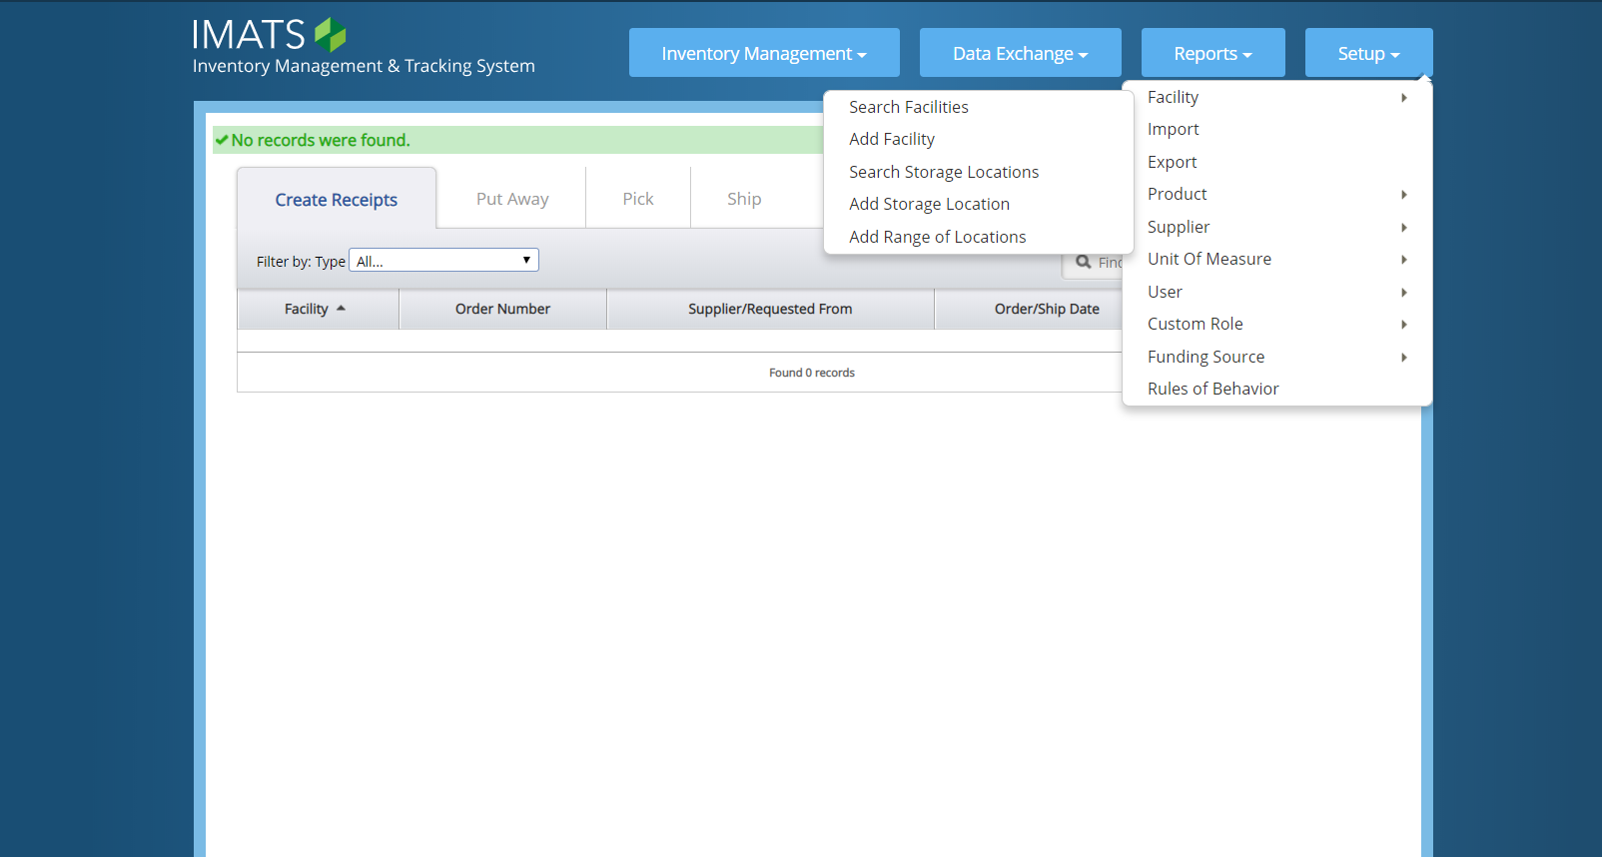

- Update Facility (pg. 29-31 in Michigan Inventory Management and Tracking System- IMATS Manual)
  - with deletions and additions as needed for both primary and backup Distribution Node and all POD sites.

- Update User (pg. 36-37 in Michigan Inventory Management and Tracking System- IMATS Manual)
- by confirming information is current and update if needed.

- Update Custom Role (pg. 38-41 in Michigan Inventory Management and Tracking System- IMATS Manual)
- by confirming all information is correct and update if needed.
- Go back to the IMATS Training Site
- and repeat updates for facilities, users, and roles as needed for accuracy and training purposes for your jurisdiction.

This completes Drill 1. Should you have any questions please contact Jeannie Byrne at byrnej2@michigan.gov

