IMATS Live Site: https://imats.cdc.gov

- Facility Update
  - Click Setup
  - Click Facility
  - Click Search Facilities (To quickly access all facilities do not put anything in the search fields)
  - Click Search
  - Review the facilities
    - Edit or Delete by clicking on the facility name
    - Add additional facilities by going to Setup, Facility, Add Facility
    - Reminder when adding a facility you must also add a storage location to that facility by going to Setup, Facility, Add Storage Location

- References
    - Refer to the following sections below or in the IMATS Manual
Search/Edit Facility
Add Facility
Add Storage Location

- User Update
  - Click Setup
  - Click User
  - Click Search Users (To quickly access all users do not put anything in the search fields)
  - Click Search
  - Review the users
    - Edit or Delete by clicking on the user name
    - Add additional users by going to Setup, User, Add User
(Note: Users must have been approved in SAMS before they will have access to the system)

- References
    - Refer to the following sections below or in the IMATS Manual
Search/Edit User
Add User

- Inventory Update
  - Click Inventory Management
  - Click Inventory
  - Click Search Inventory (To quickly access all inventory do not put anything in the search fields)
  - Click Search
  - Review the inventory
    - Edit or Delete by clicking on the inventory item name
    - Add additional users by going to Inventory Management, Inventory, Add Inventory

- References
    - Refer to the following sections below or in the IMATS Manual
Search/Edit Inventory
Add Inventory

Data can be tracked on the administrative level in IMATS, so LHD does not need to submit anything.

SEARCH/EDIT FACILITY
1 | Select Setup, then Facility and then Search Facilities. | 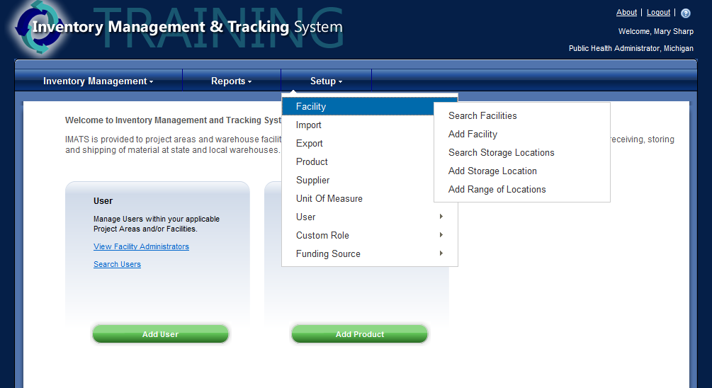
2 | Choose the search criteria and enter the information into the corresponding field.  Click Search to continue. | 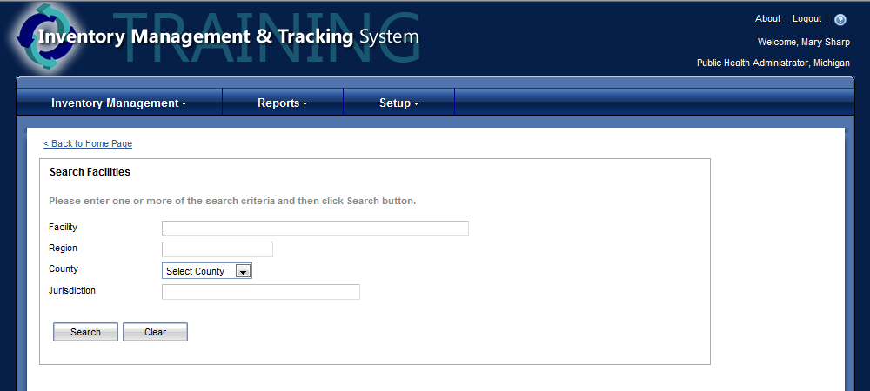
3 | If results are available they will display below the search criteria.  Choose the facility by clicking on the facility name.  *Note: If results do not display try searching without anything in the search box, this will return all available results. | 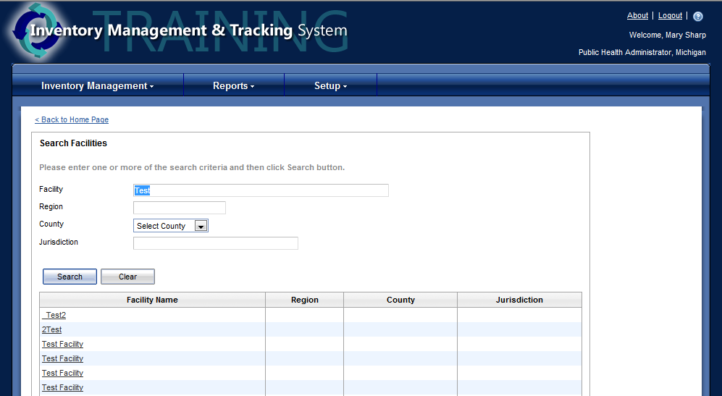
4 | Change Facility  To edit information for the facility change or add the information to the edit facility screen.  Click Save when complete.  A confirmation will appear when a facility has been successfully updated. | 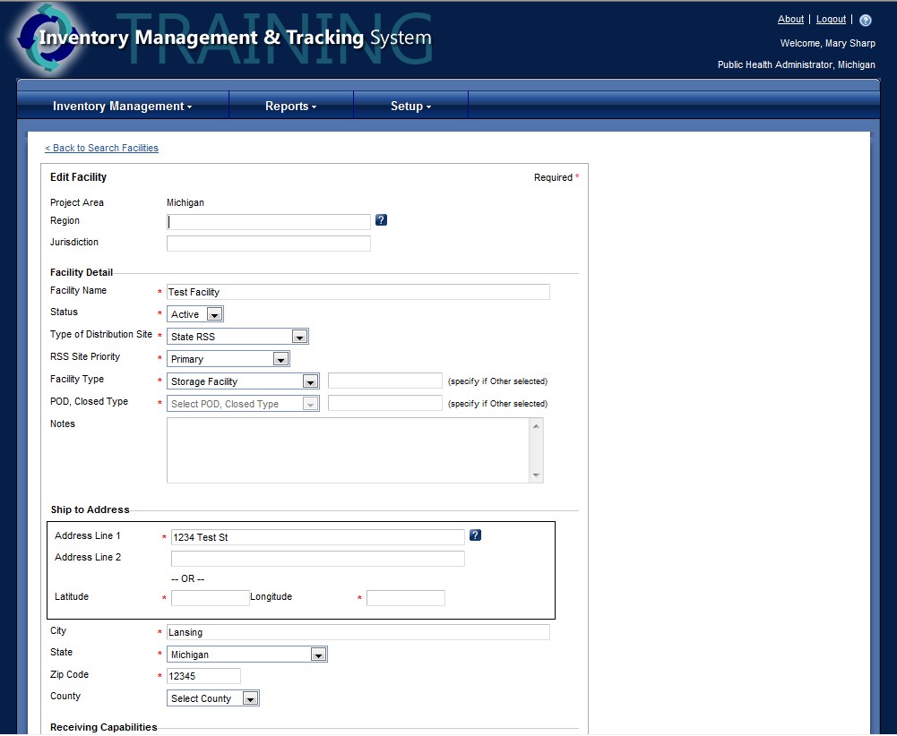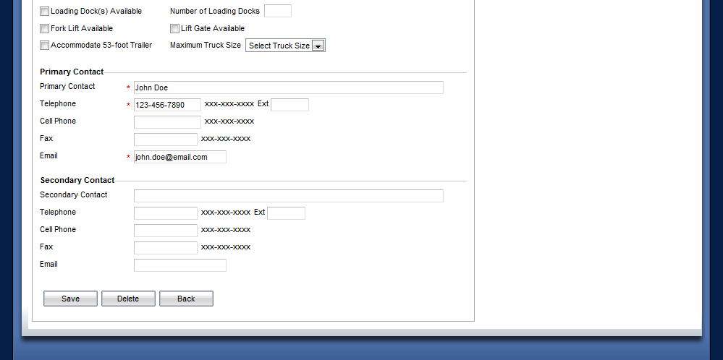

5 | Delete Facility  Click Delete on the Edit Screen.  Confirm the delete by clicking OK on the pop up.  A confirmation will appear when a facility has been successfully deleted. | 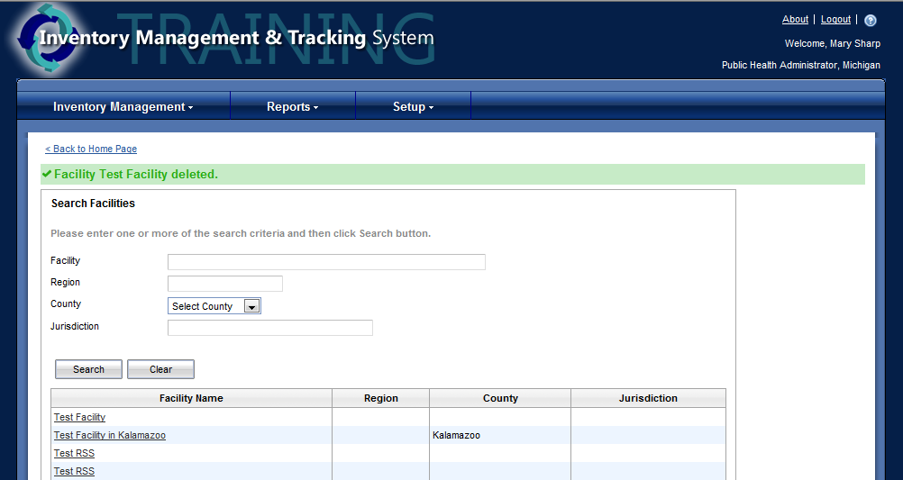
6 | Error: Facilities with users assigned to them cannot be deleted. The users must be removed from the facility before deleting. See Search/Edit User for instructions.

ADD FACILITY
1 | Select Setup, then Facility and then Add Facility.
2 | Complete the new facility fields.  * Items are required  Click Add when complete. | 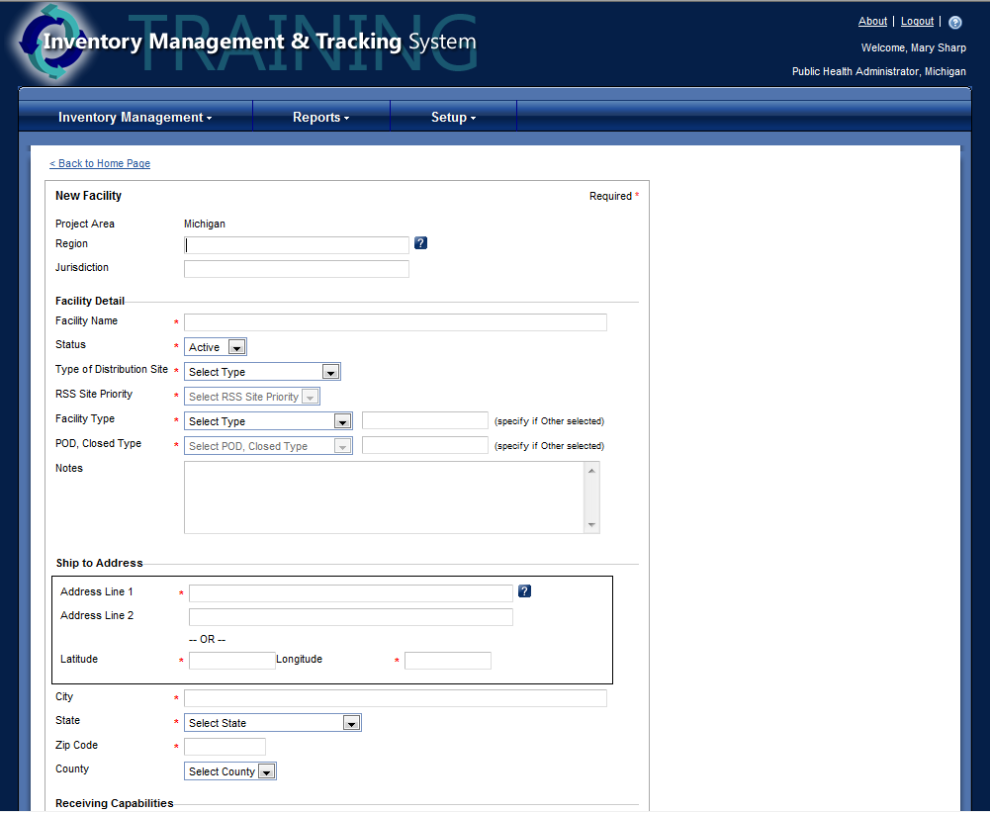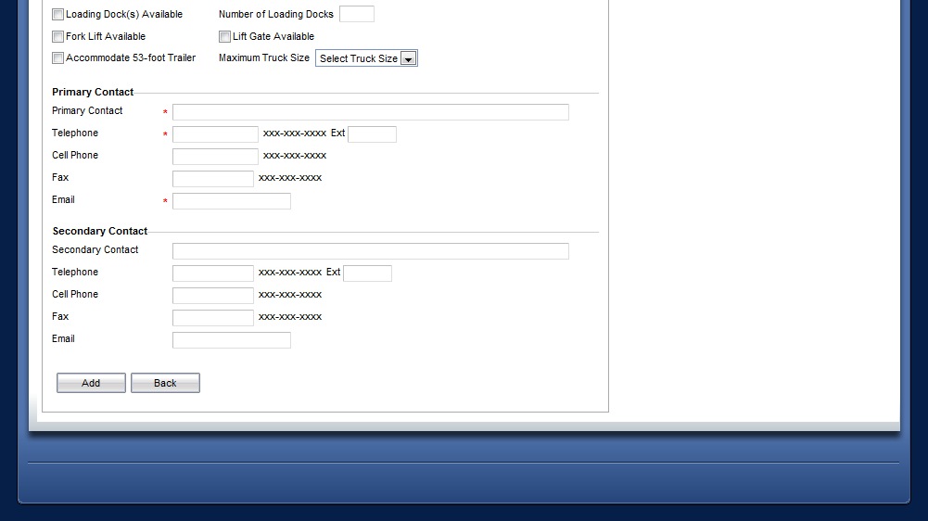
3 | A confirmation will appear when a new facility has been successfully added.  *Note: The added facility will be listed on the right and additional facilities can continue to be added. | 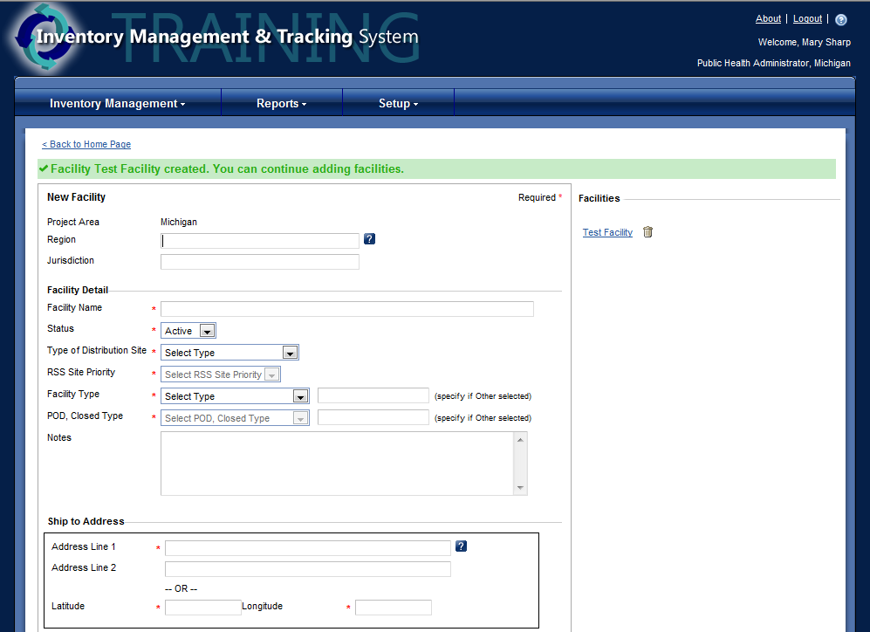

ADD STORAGE LOCATIONS
1 | Select Setup, then Facility, and then Add Storage Location.
2 | Complete the new storage location fields.  * Items are required  Click Add to continue. | 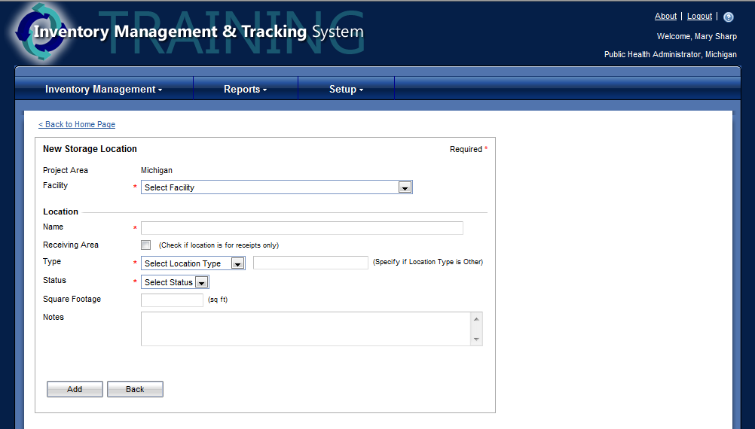
3 | A confirmation will appear when a storage location has been successfully added.  *Note: The added storage location will be listed on the right and additional storage locations can continue to be added. | 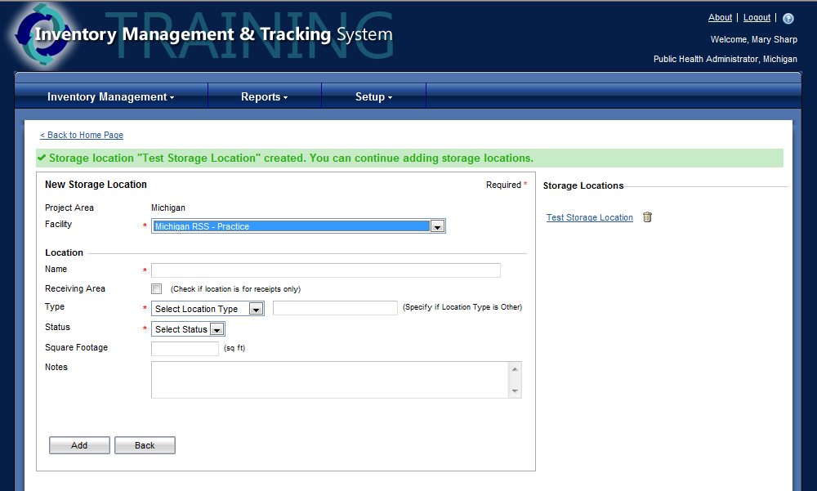

SEARCH/EDIT USERS
1 | Select Setup, then User and then Search Users. | 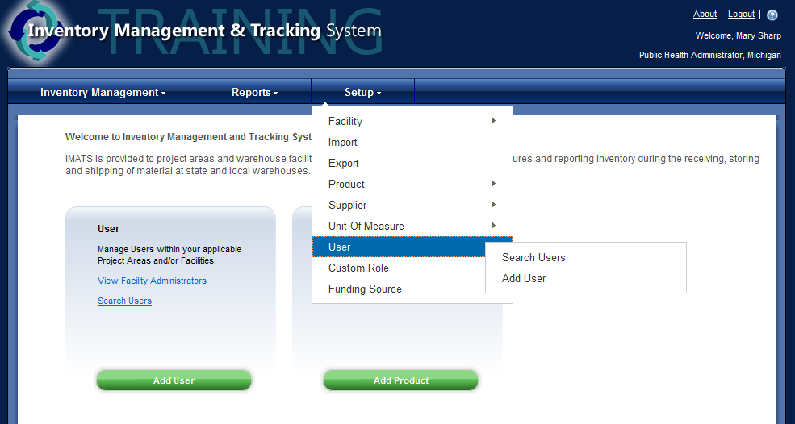
2 | Choose the search criteria and enter the information into the corresponding field.  Click Search to continue.  *Note: If results do not display try searching without anything in the search box, this will return all available results. | 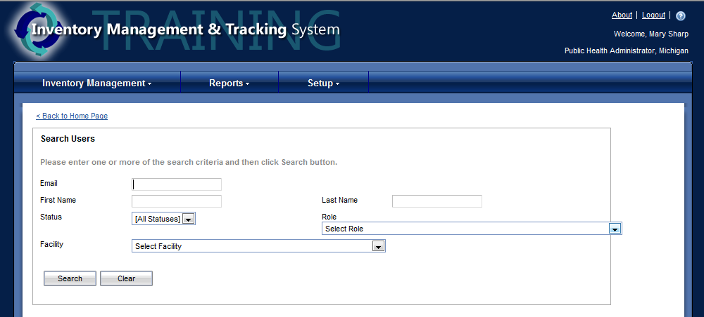
3 | If results are available they will display below the search criteria.  Choose the user by clicking on their name. | 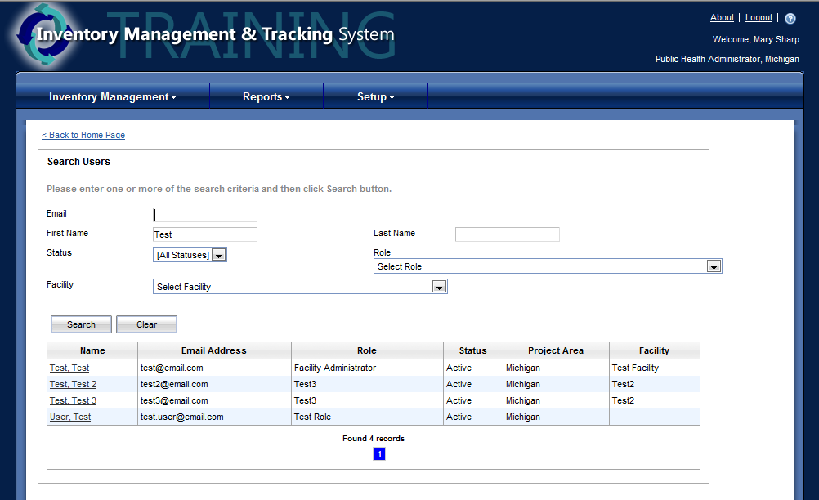
4 | Change User Information  To edit information for the user change or add the information to the edit user info screen.  Click Save when complete.  A confirmation will appear when a user has been successfully updated. | 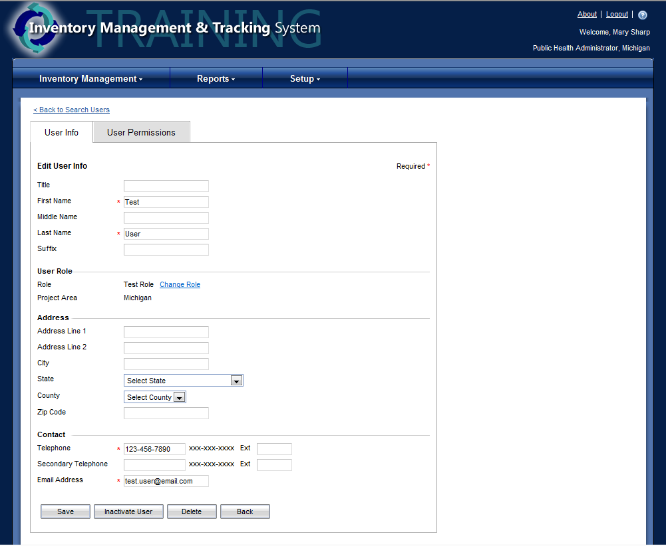

5 | Change User Role  To change the role of a user click change role in the User Role section of the User Info tab.  Use the drop down to select the new role to be assigned.  Click Next to continue.  Click the box next to the facility name that the user will be assigned to.  Click Next to continue.  Confirm the permissions for the user. Add or remove any by checking or unchecking the box next to it.  Click Done when complete.  A confirmation appears when the user role has been successfully changed. | 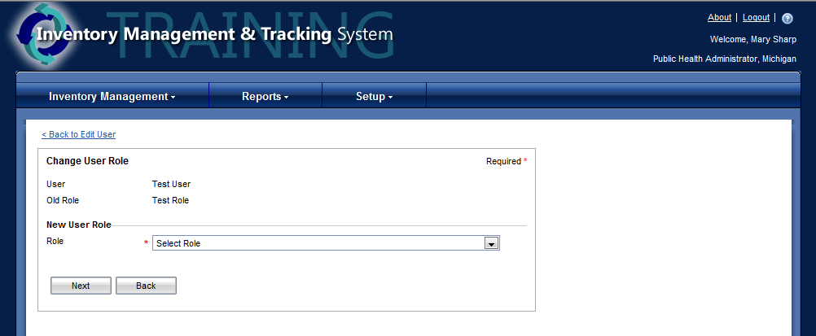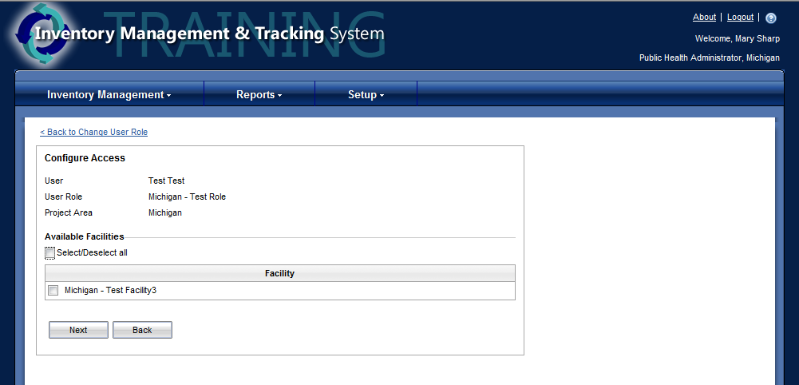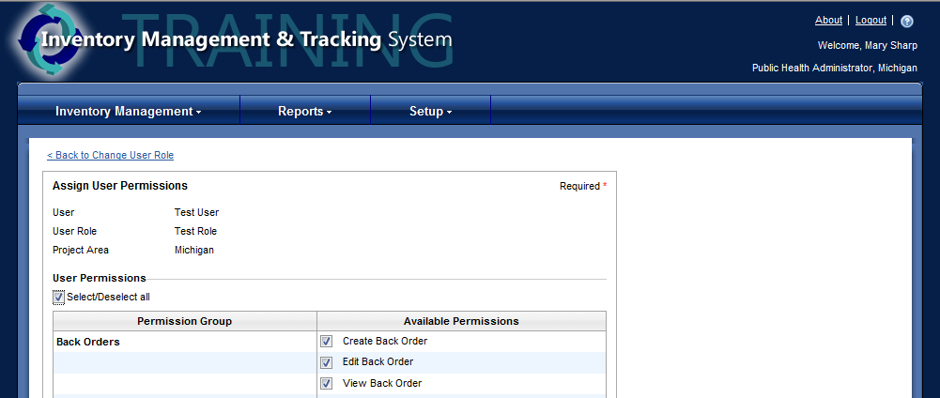
6 | Change User Access  To edit information for the user’s access change or add the information to the User Access tab.  Remove Facility: To remove an assigned facility click the trash can next to the facility name.  Add Facility: To add an assigned facility click Configure Access, then click in the check box next to the facility name.  Click Save when complete.  A confirmation will appear when user access has been successfully updated. | 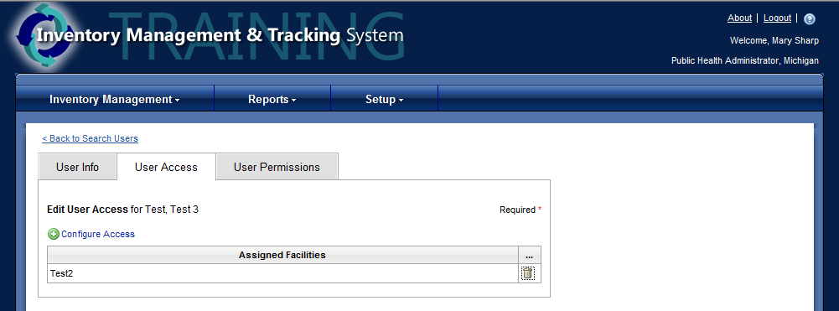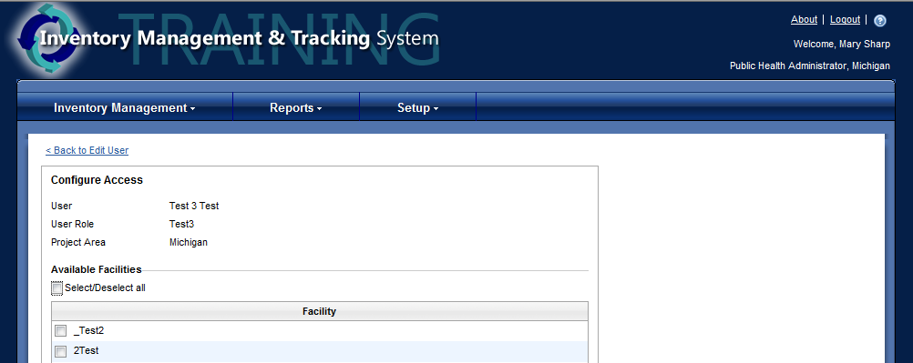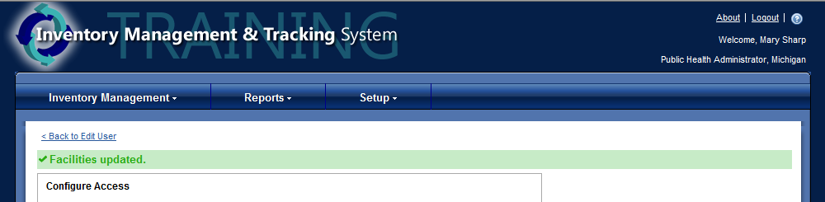
7 | Change User Permissions  To edit information for the user’s permissions change or add the information to the User Permissions tab.  Remove Permissions: To remove permissions click the trash can next to the permission name.  Add Permissions: To add permissions, click configure permissions to update, check the box for all permissions that will be added.  *Note: If no permissions are listed this means the user already has all of the permissions.  Click Save when complete.  A confirmation will appear when user permissions have been successfully updated. | 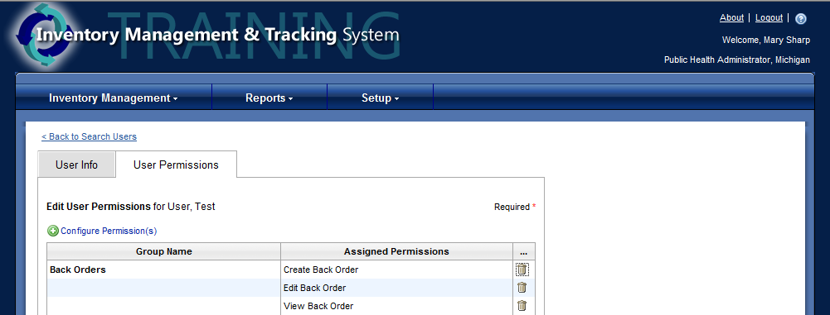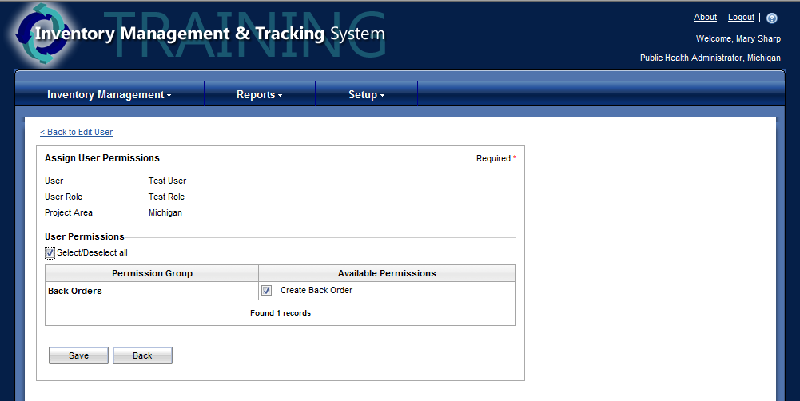
8 | Inactivate/Activate User  To inactivate or activate a user use the User Info tab.  Inactivate: To inactivate a user click Inactivate User  Activate: To reactivate a user click Activate User.  A confirmation will appear when a user has been successfully inactivated or activated. | 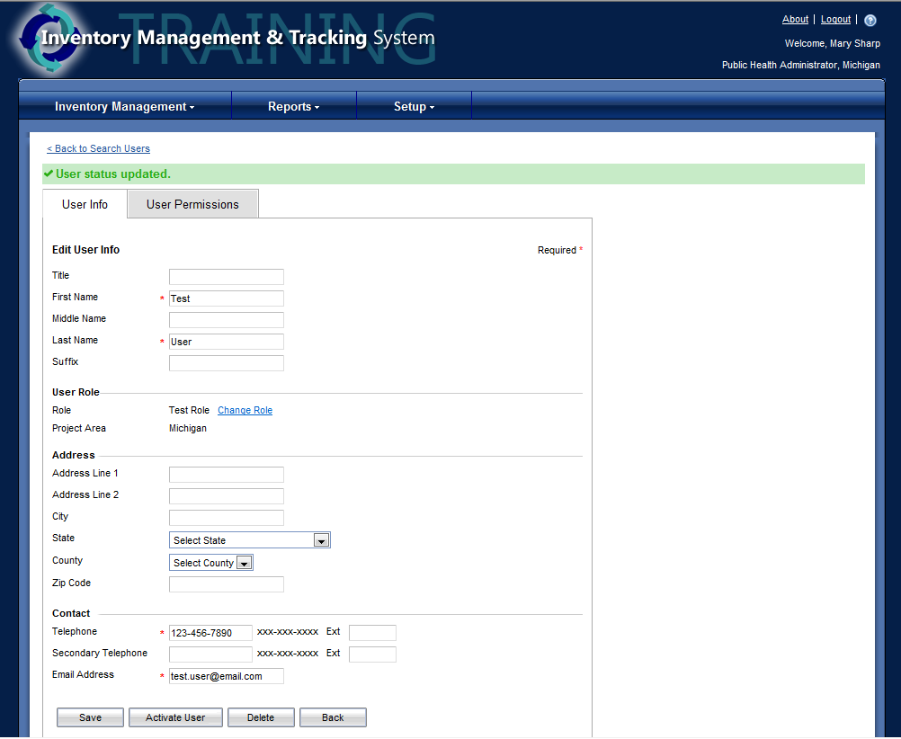  Notice that this button changes depending on the user’s status.  Active Users - have a deactivate user button  Inactive Users - have an activate user button
9 | Delete User  To delete a user click Delete on the User Info screen.  Confirm the delete by clicking OK on the pop up.  A confirmation will appear when a user has been successfully deleted.

ADD NEW USER
1 | Select Setup, then User, and then Add User.
2 | Complete the new user fields.  * Items are required  Click Next to continue. | 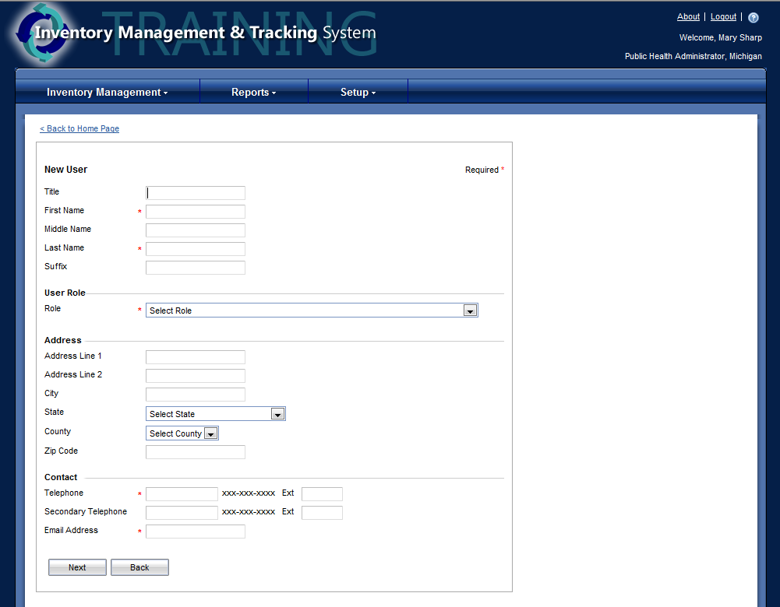
3 | Assign the user to a facility by clicking in the check box to the left of the facility name.  Click Next to continue.
4 | Select the user permissions.  Click Done when complete. | 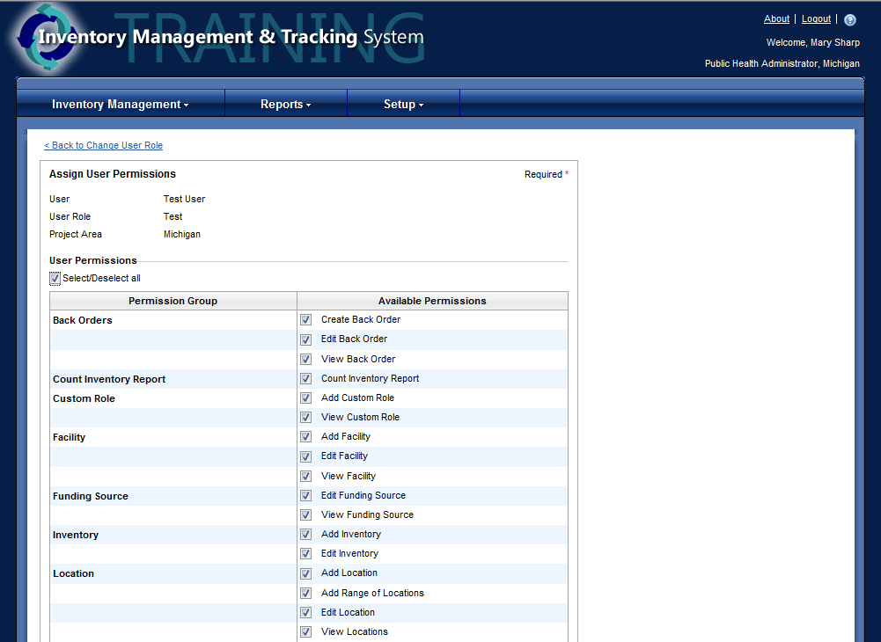
5 | A confirmation will appear when a new user has been successfully added.  *Note: The added user will be listed on the right and additional users can continue to be added. | 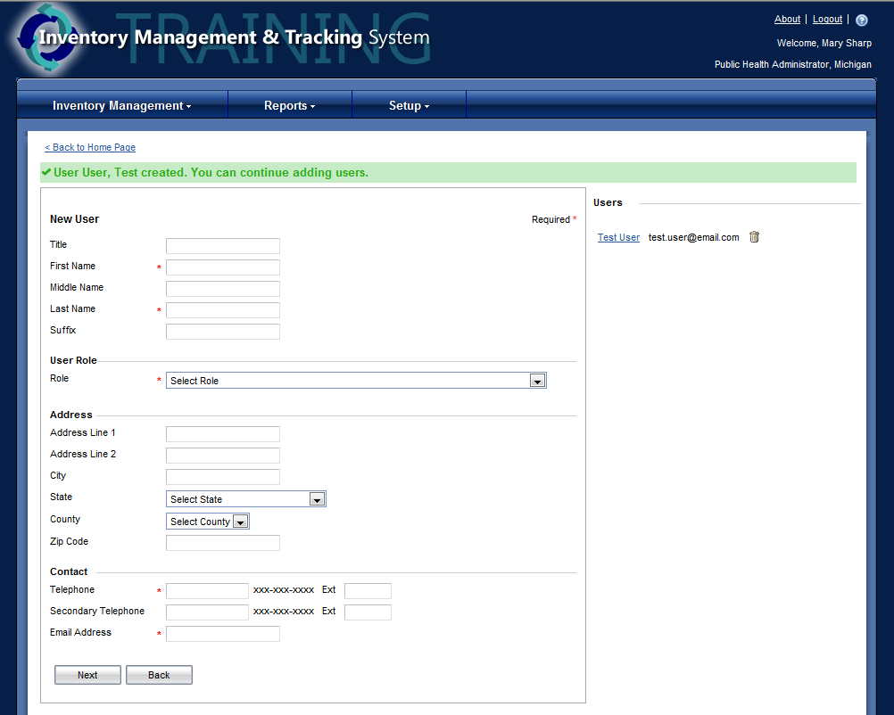

SEARCH/EDIT INVENTORY
1 | Select Inventory Management, then Inventory, and then Search Inventory. | 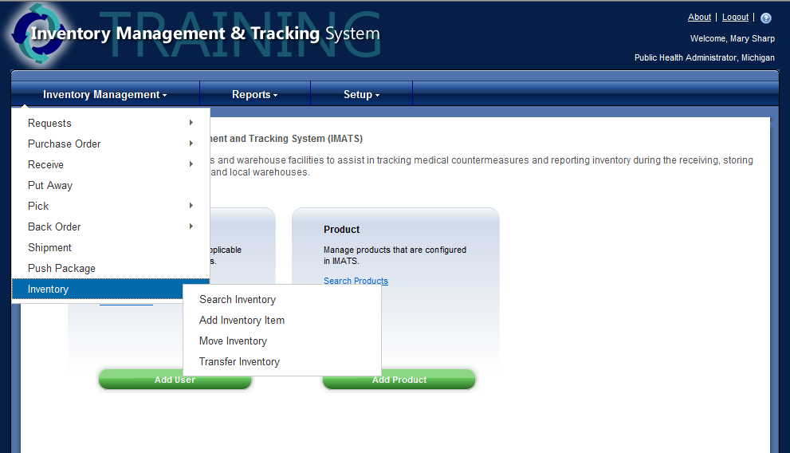
2 | Choose the search criteria and enter the information into the corresponding field.  Click Search when complete. | 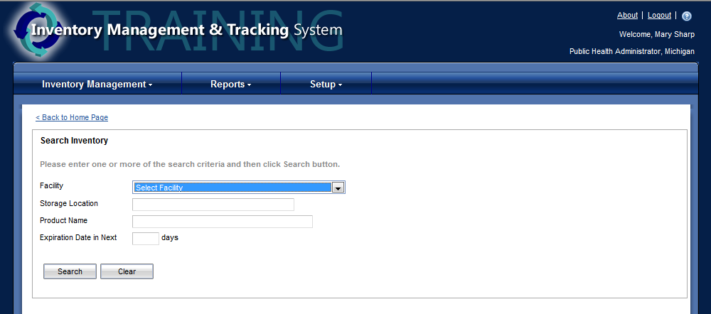
3 | If results are available they will display below the search criteria.  Choose the inventory items by clicking on the Product Name, Item Number. | 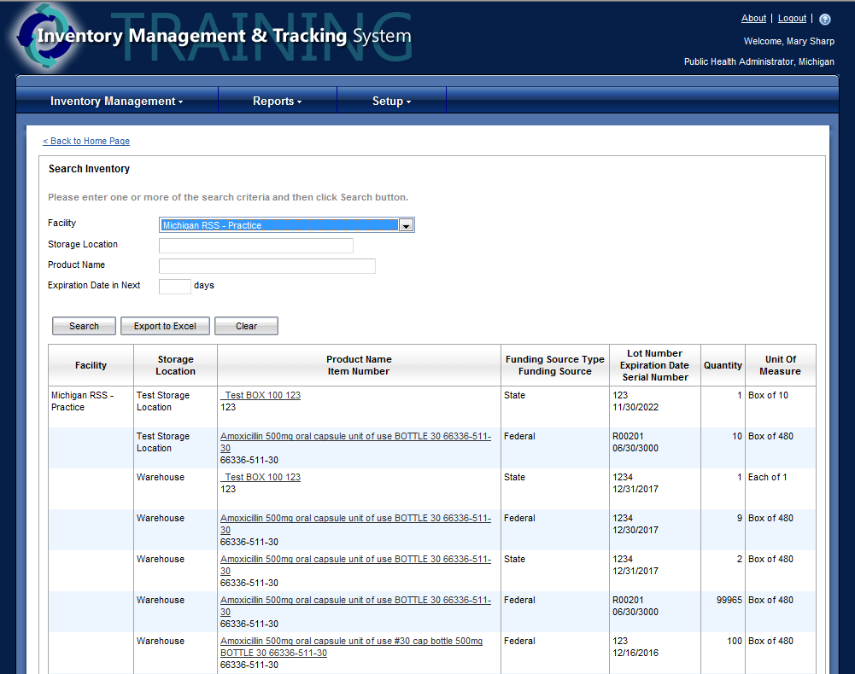
4 | Change Inventory  To edit information for the inventory items, change or add the information to the edit inventory item.  Click Save when complete.  A confirmation will appear when the item has been successfully updated. | 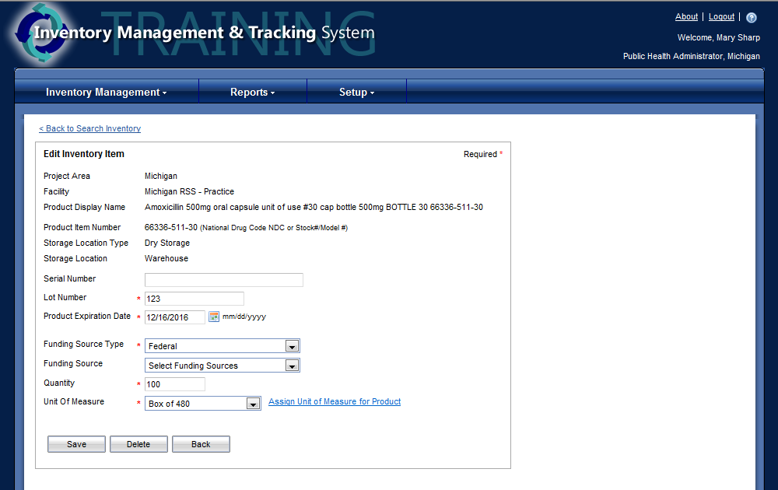
5 | Delete Inventory  To delete an inventory click Delete on the edit inventory item screen.  A confirmation will appear when an inventory item has been successfully deleted.

6 | Export Inventory  To export a list of inventory for the facility chosen click Export to Excel.  Click Save in the pop up.  It is recommended to save to the desktop.  The file type is likely going to be unknown, so the file extension will have to be changed before it can be opened after saving it. It is recommended that the file is saved to the desktop, so that it is easier to make the change to the file extension that is needed to open the file.  To change a file extension from the desktop, click the name part of the file once. This will highlight it and allow it to be edited.  Then change the .tsv to .xls and press enter.  A warning will appear, click Yes to continue.  The file will now be changed and should be able to be opened in Excel.  If a warning appears when opening the file, click Yes to continue. | 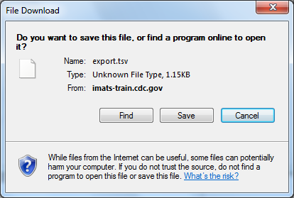  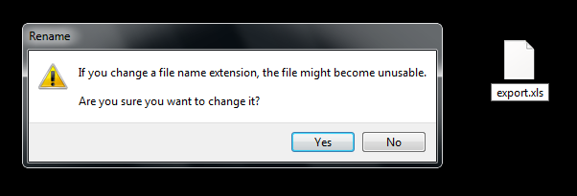

ADD INVENTORY
1 | Select Inventory Management, then Inventory, and then Add Inventory Item.
2 | Complete the add inventory item fields.  * Items are required | 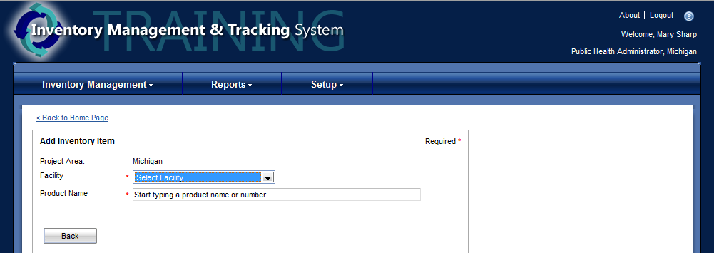
3 | A drop down will appear when information is added into the Product Name field.  After entering the item additional options will appear.  Enter any applicable information.  *Items are required.  Click Add when complete. | 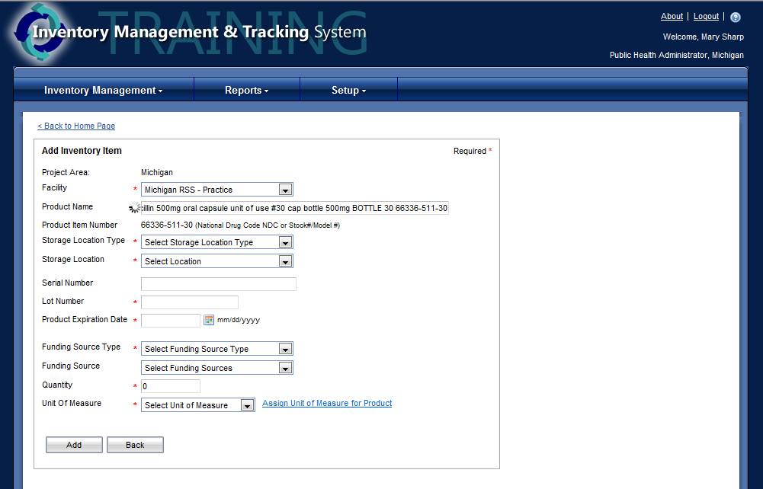
4 | A confirmation will appear when an item has been successfully added. | 